# Project Overview Statement

The Game Store project is an online platform which aims to create a digital platform similar to Steam or Xbox Game Center, designed to enable users to browse / search / subscript / like(collect) / buy the video games. We Name it as GameOne Store.

This platform caters to a wide range of users including gamers, developers, and administrators. The goal is to provide a seamless, user-friendly experience where users can browse games, make purchases, and leave reviews. At the same time, we’d like to enrich the user experience on our platform and enhance the user stickiness of users. Such as post / comment / share game experiences or insights.

For Game Developers, they can upload and manage their games, while administrators oversee platform activities to ensure smooth operations. The objective is to offer a seamless and engaging user experience for gamers while ensuring robust backend support for developers / publishers to manage their game listings.

# Requirements/Feature List

|  |  |
| --- | --- |
| Functional Requirements | |
| User Management | User Registration |
| User Login/Logout |
| Profile Management |
| Password Management / Recovery |
| Payment Maintenance |
| Game Management | Browse Games by Categories |
| Search / Filter by Multiple Dimensions(category, title, genre, developer, etc) |
| Game Detail View (View detailed information about games, including trailers, screenshots, and descriptions) |
| Add Games to Wish-list |
| Purchase Games |
| Download Purchased Games |
| User-game Library |
| Game Recommendations (Personalized game recommendations based on user preferences and purchase history) |
| Membership Management | Game Pass-card Management |
| Golden-membership Management |
| Transaction Management | Shopping Cart |
| Checkout Process |
| Payment Gateway Integration |
| Order History |
| Review System | Add game reviews |
| View reviews and ratings |
| Rate reviews as helpful or not |
| Post System | Publish personal Post about Games/Review/Experiences |
| Follow liked posters |
| Add Comment / Like / Dislike in posts |
| Share the post to social media platform |
| Developer Features | Developer registration and profile |
| Game Publish / Upload / Update and Management |
| Sales and Download Statistics |
| Administrative Features | User Management |
| Game Approval/Rejection |
| Review Moderation |
| Financial Reports Export |
| Additional Features | Notifications (email, in-app) |
| Promotional offers and discounts |
| Multilingual support |

|  |  |
| --- | --- |
| Non-functional Requirements | |
| Security | Robust Security Measures |
| Secure Payment Processing |
| User Data Privacy and Protection |
| Scalability | Scalable Arhitecture |
| High Availability and Reliability |
| Performance | Personalized Game Recommendations |
| Comprehensive Analytics and Reporting |
| Usability | Responsive Customer Support |
| Intuitive and Engaging User Interface |
| Community Features for Enhanced Engagement |

# Feature Tree Diagram

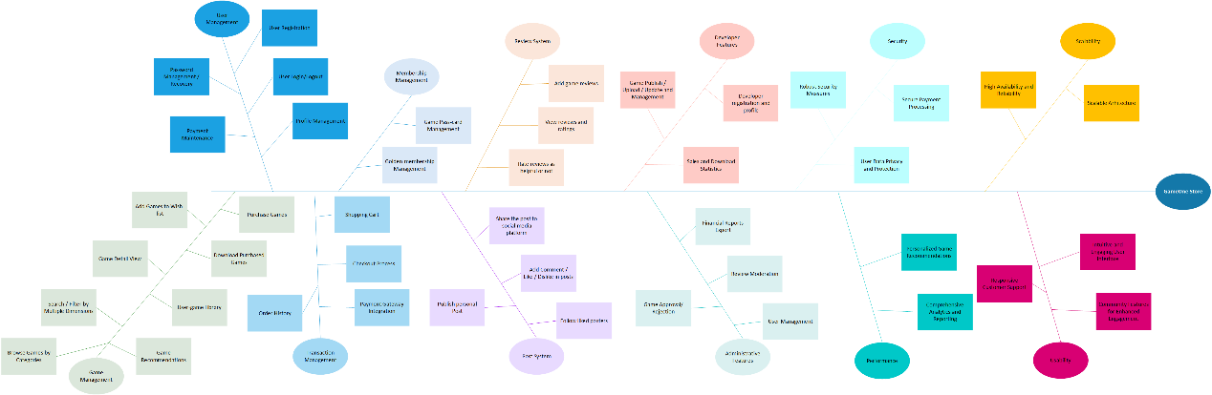

# Domain Dictionary

|  |  |  |
| --- | --- | --- |
| **Name** | **Type** | **Description** |
| User | Role | An individual who uses the Game Store platform. |
| Developer | Role | A user who submits and manages games on the platform. |
| Administrator | Role | A user with elevated privileges for managing the platform. |
| Game | Object | A digital product available for purchase or download. |
| Review | Process | Feedback provided by users about a game. |
| Browse / Search | Process | The process of searching a game |
| Subscript / Like(Collect) | Process | Th process of Subscribe / Like(collect) a game, after this operation it will be added to Wish List |
| Transaction | Process | The process of purchasing a game. |
| Post | Process | The Process of posting a post about games, including the experience / rates. |
| Wish List | Object | A list of games a user is interested in purchasing later. |
| Notification | Object | Messages sent to users about updates, offers, or other information. |
| Shopping Cart | Object | A virtual cart where users can add games before purchasing. |
| Payment Gateway | Process | A service that processes credit card payments for transactions. |
| Library | Object | The collection of games owned by a user |

# Actor Dictionary

|  |  |  |  |
| --- | --- | --- | --- |
| **Actor** | **Description** | **Abstraction** | **Use case(s)** |
| User | Any visitor to the Game Store who can browse and purchase games. | Yes | 1. Register 2. Login 3. Logout 4. Browse Games 5. Search Games 6. View Game Details |
| Registered User | A user who has created an account and can access additional features like the wish list and review system. | No(inherit from the User) | 1. Edit Profile 2. Add Game to Wish List 3. Purchase Game 4. Download Game 5. View Order History 6. Write Review 7. View Review 8. Rate Review 9. Receive Notifications 10. Subscribe/Follow Game 11. Publish Post 12. Share Game 13. Share Post 14. Comment Post |
| Developer | A registered user who submits and manages their games. | No(inherit from the User) | 1. Submit Game 2. Manage Submitted Game Listings 3. View Sales Statistics from themselves 4. View/Respond the Games’ Feedback 5. Fix Bugs |
| Administrator | A registered user with permissions to manage the platform, including user management and content moderation. | No(inherit from the User) | 1. Manage Users 2. Approve Games 3. Reject Games 4. Review/Approve/Reply/Delete user reviews 5. View All Sales Statistics 6. Generate Financial Reports 7. Send Notifications |

# Use Case Diagram

1. Register
2. Login
3. Logout
4. Check If User Exist
5. Browse Games
6. Search Games
7. View Game Details
8. Edit Profile
9. Add Game to Wish List(Subscribe / Like Game)
10. Check If the Game In list
11. Purchase Game
12. Download Game
13. Check Download Condition
14. View Order History
15. Write Review
16. View Review
17. Rate Review
18. Receive Notifications
19. Publish Post
20. Share Post
21. Comment in Post
22. Submit Game
23. Check the Game is Approved
24. Manage Submitted Game Listings
25. View Sales Statistics from themselves
26. View/Respond the Games’ Feedback
27. Fix Bugs
28. Manage Users
29. Approve Games
30. Reject Games
31. Review/Approve/Reply/Delete user reviews
32. View All Sales Statistics
33. Generate Financial Reports
34. Send Notifications
35. Check If Subscribe the Notifications

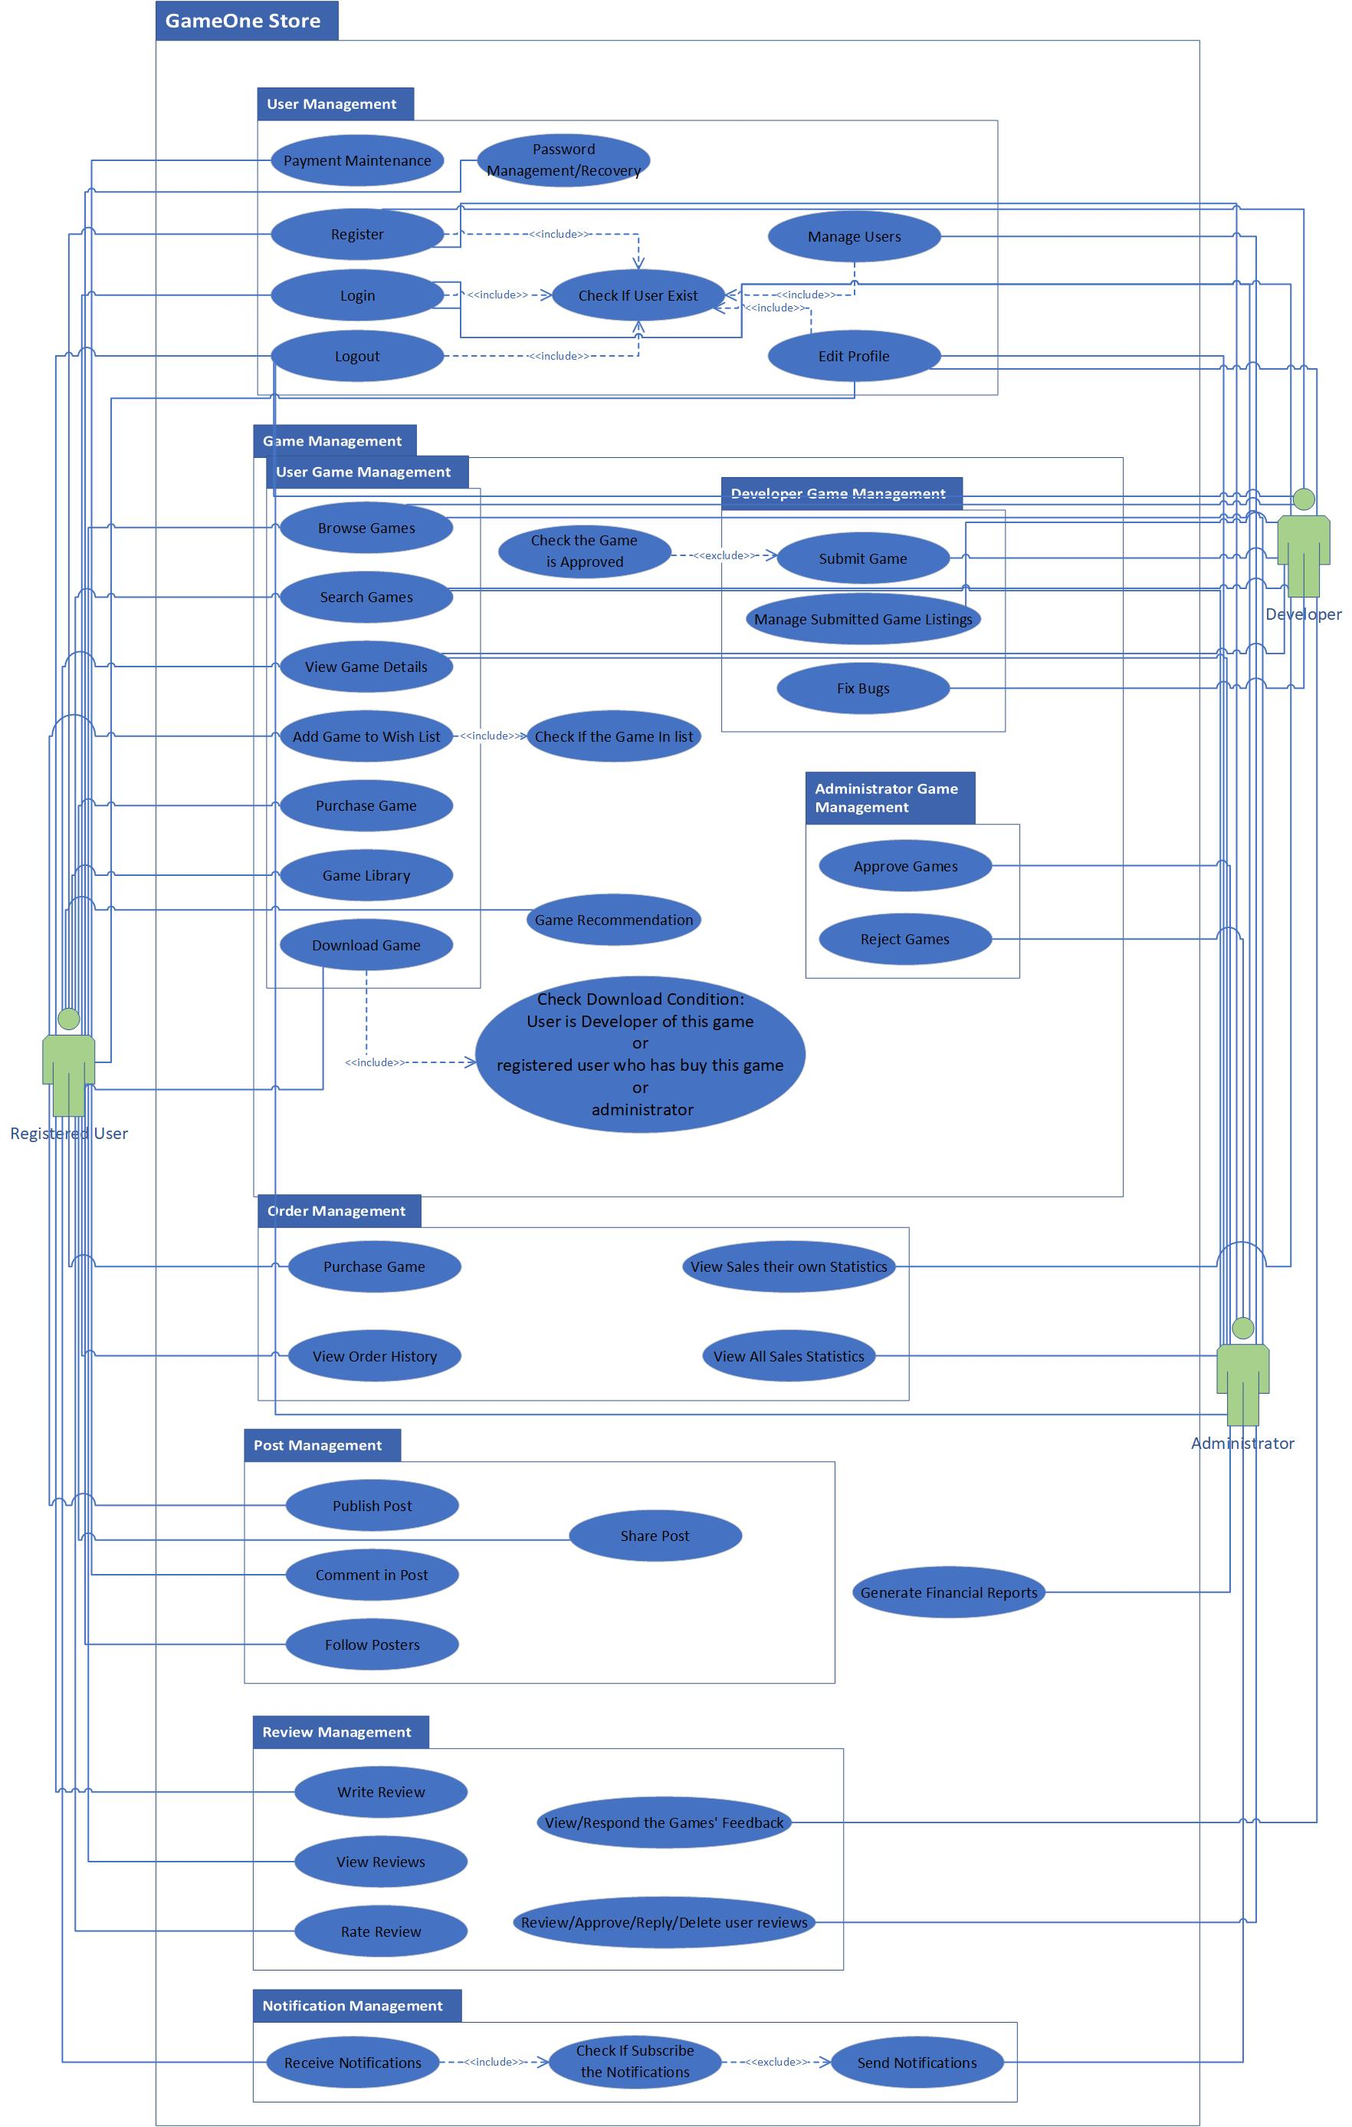

# Analysis Model

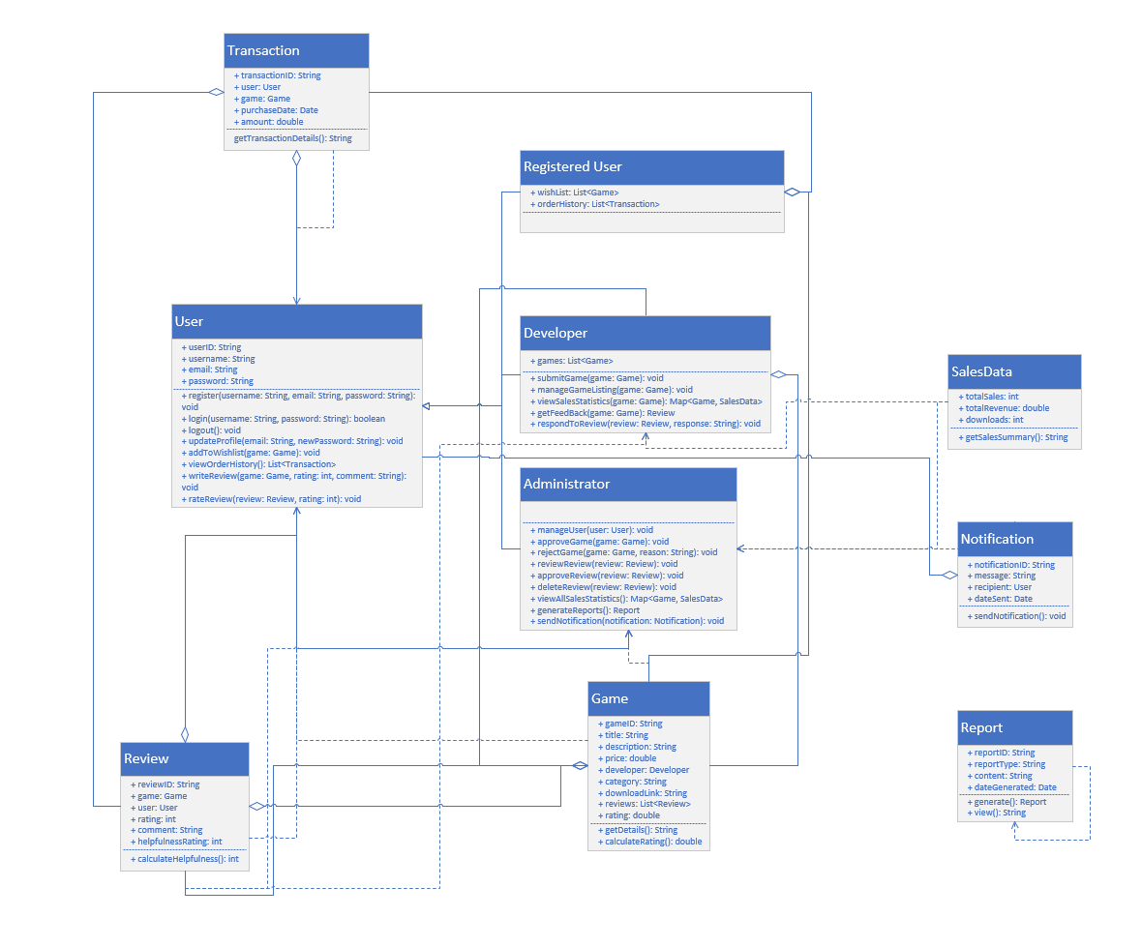

# Interaction Sequence Diagrams